

**User Manual**

**Index**

About SOS Hotel Search………………………………..………2

Dependencies………………………………………………………2

Installation…………………………………………………………..2

Usage

Creating an Account and Logging In…………………2

Hotel Searcher Usage

Navigating the Application…………………………...…3

Searching for a Hotel…………………………………..….3

Selecting a Hotel…………………………………………....3

Viewing and Booking a Hotel……………………..…..4

Payment……………………………………………………..….4

Writing a Review…………………………………………….4

Viewing Reservations……………………………………..4

Hotel Owner Usage…………………………………………….5

**About SOS Hotel Search:**

SOS Hotel Search is a java-based application that offers helpful features to users looking for a hotel. Users can search for hotels by location, price, and rating to find the perfect hotel for their next trip. The results will be displayed on a list alongside a map, and users are able to choose a hotel and book a reservation. Hotel owners can also make an account, and they can view reservations for their hotels.

**Dependencies:**

* Java 8
* Derby Embedded Library
* JxMaps API
* Must have internet access to display the map

**Installation:**

Double click on the SOS Hotel Search .jar file to run the program.

NOTE: If the program does not run, or you seem to be stuck on the login/register screen, please run the application through the command line. You can do this by pointing to the directory of the SOSHotelSearch.jar file (for example, in command line type "cd C:/users/yourName/SOSHotelSearch-master/SOSHotelSearch_jar") and then running the command "java -jar SOSHotelSearch.jar".A screenshot of a cell phone

**Usage:**

**Creating an account and logging in:**

When the application opens, it will begin on the login screen. If you don’t have an account, click “Sign up” in the top-right part of the screen and you will be brought to a new screen to create an account. Fill in the information for the following required fields to create your account:

* Full Name: at least two letters
* Username: alphanumeric
* Password: any combination of letters, numbers, and special characters
* Email: any email address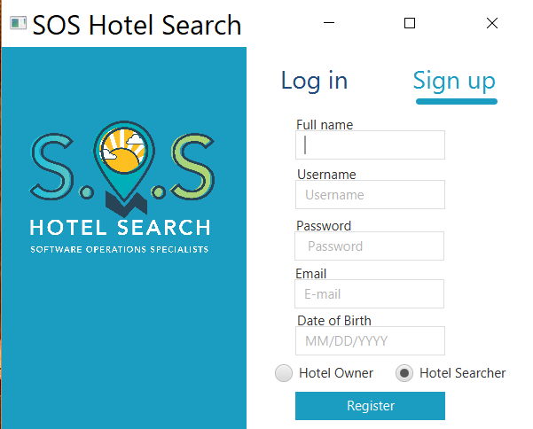
* Date of Birth: MM/DD/YYYY

Select whether you are a hotel searcher or a hotel owner and click “Register”, and your account will be created. You will be able to edit your account information at any time. Now that your account has been created, you will be able to login using the username and password for your account.

**Hotel Searcher Account Usage:**

**Navigating the Application:**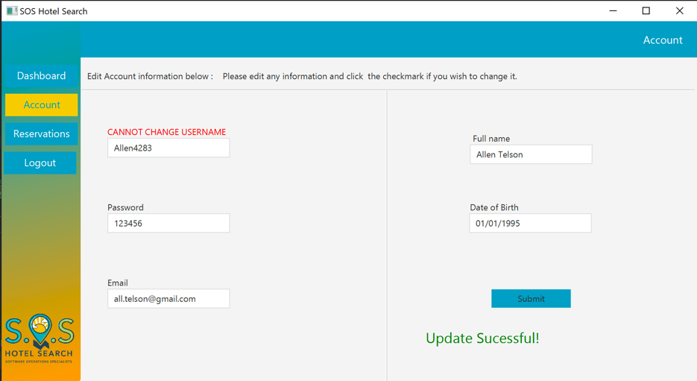

At any time, you may click the tabs on the left side of the screen to access different parts of the application. You can click “Dashboard” when you want to search for hotels, “Account” when you want to edit your account information, “Reservations” to view a list of the reservations that you made, and “Logout” to logout of your current account and go back to the login screen.

**Searching for a hotel:**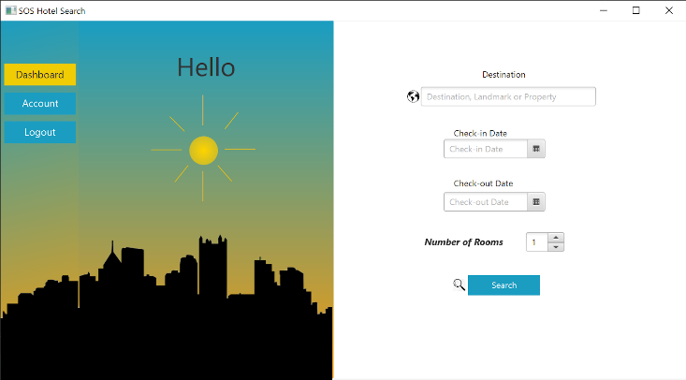

After logging in as a hotel searcher, you will be brought to the dashboard screen. Enter a desired location in the “Destination” field (e.g. Boston, Ma). Click in the fields for the check-in and check-out dates to select your days from a calendar. Then, select the number of rooms you want to reserve and click “Search”.

**Selecting a hotel:**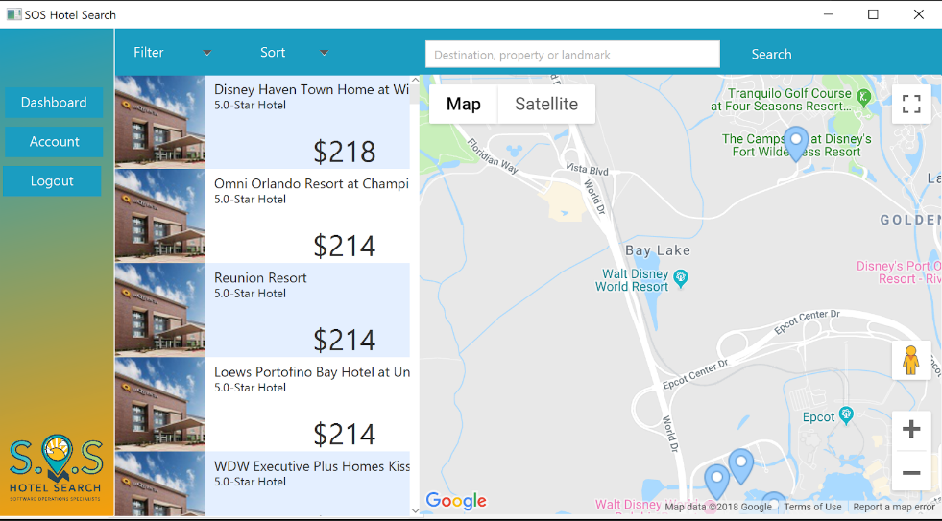

Once the initial search is performed, a list of hotels will be displayed on the left side of the screen. These hotels will also show on a map on the right part of the screen. Click on “Sort” above the map, and you will be able to sort the list of hotels by price. You may also search a different location by using the search field above the map. Once you found a hotel to your liking on the list, click on it to view more details about it.

**Viewing and booking a hotel:**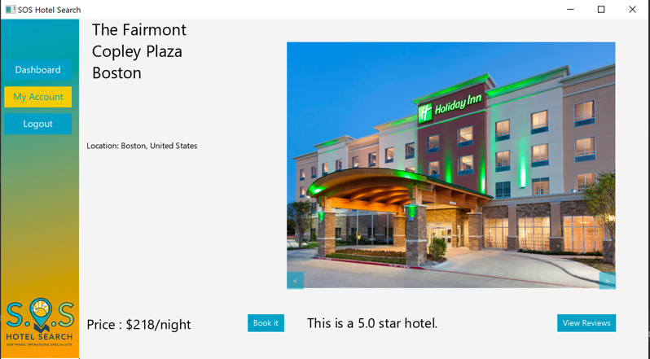

After clicking on a hotel, you will be brought to a new screen to see details about the hotel. You can scroll through photos of the hotel by clicking arrow buttons at the bottom corners of the hotel images. When you have decided on a hotel click the “Book it” button and you will be brought to the payment screen.

**Payment:**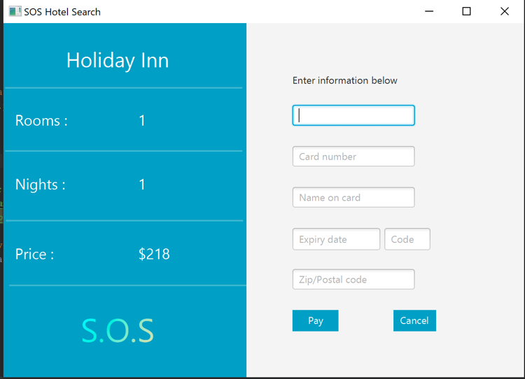

On the left side of the payment screen, it shows the number of rooms and nights you have chosen, and it will list the final cost. The final cost is calculated with (price * rooms * nights). You may fill out the text fields on the right side of the screen to put in how you will be paying, but for the sake of this prototype, it does not require the payment information. Click “Pay”, and the reservation will be made. You will be brought to a thank you screen to confirm that the reservation has been made.

**Writing a Review:**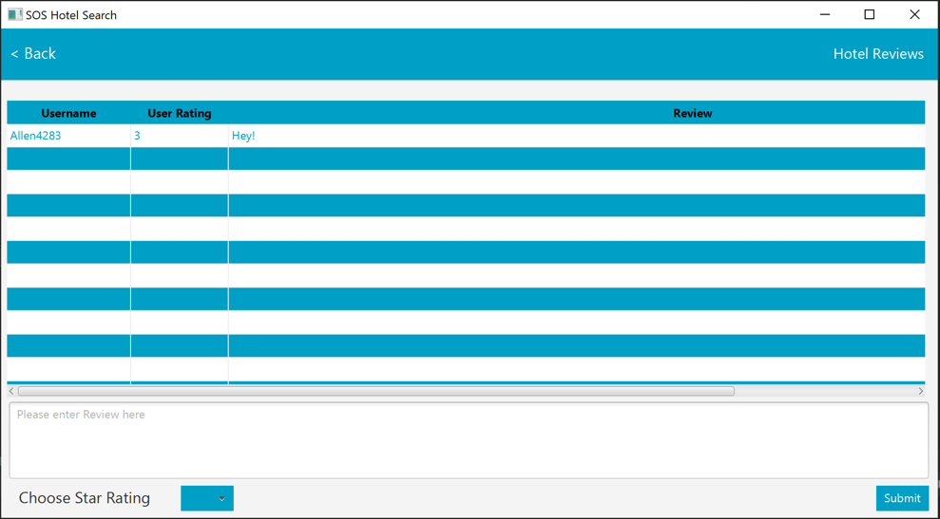

You can see reviews by clicking on “View reviews”. From here, you can write your own review of the hotel. Click in the large text box at the bottom and type your review here. Then, click on the button at the bottom of the screen to choose a star rating. Select a rating to give to the hotel from one to five. Once your review is finished, submit your review by clicking the button in the bottom right corner of the screen.

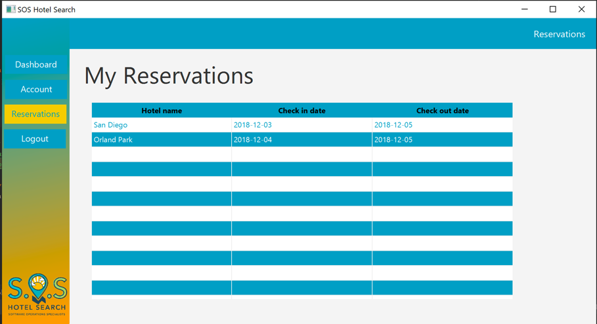

**Viewing Reservations:**

You can view the reservations that you made by clicking the reservations tab on the left side of the screen. This will provide a list of your reservations, where it will tell you which hotels you made reservations for, and the check-in and check-out dates.

**Hotel Owner Account Usage:**

To make a hotel owner account, follow the same steps that you took to make a hotel searcher account, except click the hotel owner radio button instead of the hotel searcher radio button. You will be brought to a screen where you can view what reservations were made for your hotels. The screen will show you a list of your hotels with information about each reservation, including the hotel name, the check-in date, the check-out date, and the number of rooms.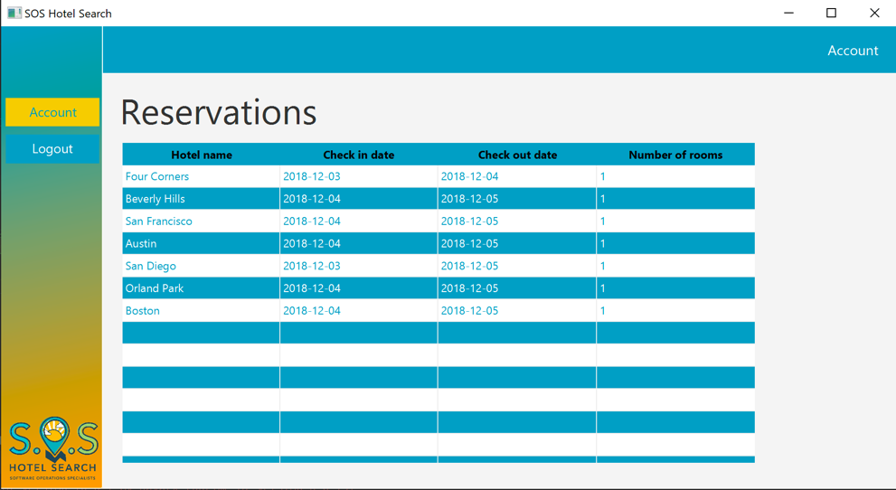

**Thank You!**Now you should be able to use all functionality of the application. Thank you for using SOS Hotel Search!